Business Requirements Document

For Business Intelligence *v1.0*

Project ID: WG000001

Project Name: Resume Recommendation System

Project Manager Name: Samuel Wolfe

Document Author Name: Samuel Wolfe

Revision Number: 3

Document Date: March 26, 2024

**Approved By: Samuel Wolfe**

**Reviewed By:**

|  |  |
| --- | --- |
| Samuel Wolfe **Project Manager** | Samuel Wolfe, **Infrastructure** |
| Samuel Wolfe, **Development** | Samuel Wolfe, **QA** |
| Samuel Wolfe, **Security** |  |
|  |  |
|  |  |

**Table of Contents**

1. Purpose 1

2. Business Metric Requirements 1

2.1 Business Gains 1

2.2 Sustainability Value Analysis 1

2.3 Key Business Questions/Drivers 1

3. Business Design 2

3.1 Existing Business Process Diagram (As-Is) 2

3.1.1 Existing Business Process Details 2

3.1.2 Information Flow Diagram 2

3.2 Proposed Business Process Diagram (To-Be) 2

3.2.1 Proposed Business Process Details 2

3.2.2 Information Flow Diagram 2

3.3 Use Cases 2

3.4 User Stories (for Agile Path) 2

3.5 Business Intelligence Design Inputs 3

3.6 Business Intelligence Metrics Collection 3

3.7 Analytic Needs 3

3.8 Operational Needs 3

4. Requirements 4

4.1 BI Requirements List 4

4.2 Screen Layouts or Prototypes 4

4.3 Report Layouts 4

4.4 Non-Functional Requirements 5

4.5 Information Availability Requirements 8

4.6 Availability 9

5. Supporting Information 9

5.1 Assumptions 9

5.2 Exclusions 9

5.3 Training Requirements 9

5.4 Review Records 9

6. References 9

6.1 External Items 9

7. Revision History 10

8. Abbreviations 10

9. Glossary 10

# Purpose

Business Requirements Document (BRD) ensures that the project is driven by customer needs and a return on investment.

| Topic | Response |
| --- | --- |
| What will the BI solution developed in this project do? | Assist Human Resource Specialists select better candidates during the hiring process through machine learning analysis in a human readable format to provide employers with the best available candidate specific to the job posting presented online. |
| Who is going to use the output of this solution? | Human Resource Specialists or other individuals responsible for selecting candidates for job interviews. |

Human Resource Specialists often must filter applicants without any prior knowledge of what the position truly requires. Current methods usually focus on keyword or aspect filtering to narrow the candidates to a human manageable number. This still puts a heavy emphasis on disconnected or subject ignorant individuals in charge of presenting the final group of candidates a hiring manager can select from for interviews. This takes many working hours to process and can inadvertently impact the quality of the selected candidates for the hiring manager’s pool.

WolfGlyph Resume Recommendation System seeks to reduce the number of working hours required by Human Resources or other individuals responsible for selecting candidates for job interviews in making those selections. At the same time, the Resume Recommendation System seeks to improve the quality of selected candidates.

# Business Metric Requirements

# The following are the metrics the Resume Recommendation System will be graded on.

# Resume Recommendation System Processing Time vs Standard Methods Today

* Human Readable Output Report

## Business Gains

The following are non-numeric improvements to the business hiring process that may be attained using the Resume Recommendation System.

* Better candidates for hiring interviews
* Relieved subject matter specialist requirements from individual selecting candidates
* Reduction in bias from keyword filtering

## Key Business Questions/Drivers

| **KBQ ID #** | **Key Business Questions or Drivers** | **Submitted by** |
| --- | --- | --- |
| KBQ1001 | Can the Resume Recommendation System accurately filter raw text files into machine learning manageable data? | Samuel Wolfe |
| KBQ1002 | Can the Resume Recommendation System provide human readable output to the end user? | Samuel Wolfe |
| KBQ1003 | Can the Resume Recommendation System correctly select the “best” candidates for interviews? | Samuel Wolfe |

# Business Design

## Existing Business Process Diagram (As-Is)

Image 1 - Existing Position Recruitment Process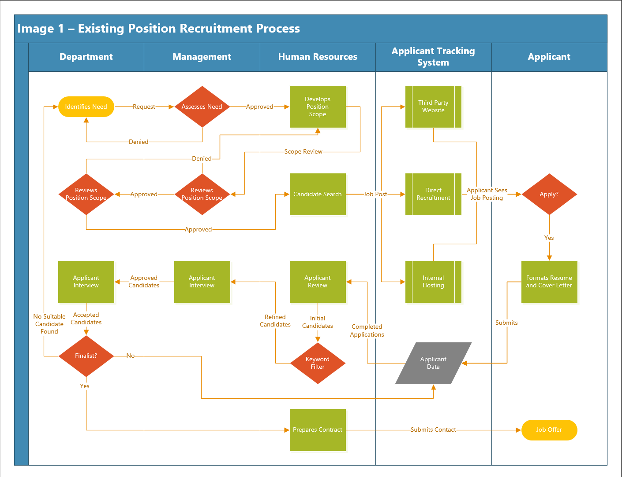

### Existing Business Process Details

1. Company Y’s Department finds they need another employee to handle additional tasks 1,2, and 3.
2. Company Y establishes how to publicize the new position, how the position will fit in the company, and scopes out the job duties for the new position.
3. Company Y hiring staff compiles a list of basic, desired, and/or critical scope requirements. These become the keyword filter used later in the process.
4. Company Y follows through on the publication plan formulated during step 2.
5. Company Y may also reach out directly to interested parties internally desired. For critical positions this is highly recommended.
6. Company Y uses their applicant tracking system to store applicants. Then a human resource staffer reviews all applicants based on the requirements outlined in set 2, primarily using the keyword filter established.
7. Company Y begins conducting initial contact and interviews. Often this process is done by the human resources staffer.
8. Company Y begins conducting secondary interviews with selected candidates.
9. Company Y assembles all compiled data, beginning the review process for potential hiring candidate selection. During this phase Company Y is encouraged to conduct additional interviews or testing as required to reduce the number of available candidates.
10. Company Y is encouraged to do background checks at this stage. Background checks are expensive and time-consuming. Doing them at this step reduces time and material investment in undesirable candidates.
11. Company Y is encouraged to do reference checks at this point. Reference checks are expensive and time-consuming. Doing them at this step reduces time and material investment in undesirable candidates.
12. Company Y makes primary and secondary choices. If no candidate is selected, Company Y may need to restart the Position Recruitment process over, adjusting details as needed until the process is successful.
13. Company Y either receives confirmation from Primary or Secondary finalist choice accepting the job offer. At this step Company Y will begin compiling a total job offer package. This package should include all necessary information for the candidate to make a final decision or negotiate changes.
14. Company Y begins the hiring process once the candidate accepts a job offer. This process usually falls into the human resources department scope.
15. Company Y begins staging welcoming events, training, and orientation for the new employee.

### Information Flow Diagram

Image 2 – Existing Position Recruitment Process Information Flow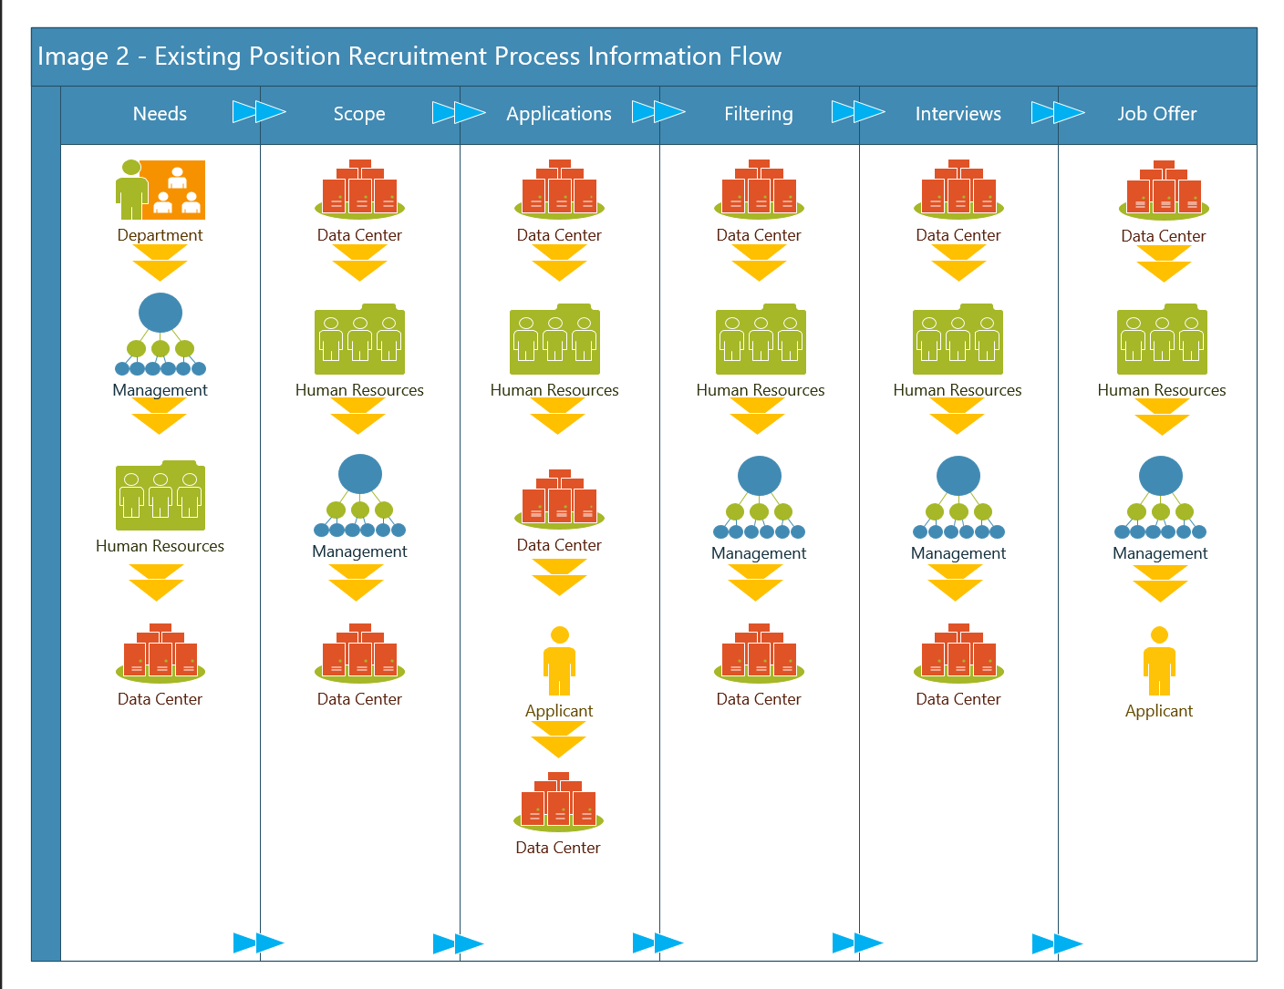

The current information flow diagram is presented above. Below is a breakdown of the critical information required within each column and an outline of how the data is changed through the process. It is assumed that all data starts and finishes within the Data Center the company uses to store data.

Needs – The Department identifies a need that can be filled with additional staffing. Department Leads create document detailing the need and present this to Upper Management. If Upper Management agrees with the Department assessment the document is handed off to Human Resources.

Scope – Human Resources takes the established Needs document and develops a scope of work for a new position. When this is completed, Human Resources presents the finalized position to Upper Management.

Applications – Human Resources hosts the job application post on internal or third-party applicant tracking systems. This enables potential candidates to find and apply for the new positions. As the candidate applications come in the company central Data Center can begin gathering all applications. It is at this stage that the data is the rawest as the applicant tracking systems are usually dealing with blocks of text from PDF or Word Document files.

Filtering – This stage sees the candidates keyword filtered for initial selection by the Human Resources department. This process is sometimes automated but is often a manual process. After initial keyword filtering the remaining candidates are pushed to Upper Management for further selection.

Interviews – At this stage Human Resources makes initial contact with candidates and performs brief interviews. Then Management forms interview panels and processes all selected candidates through. At this point the pool of candidates is much reduced and very little data processing is required to proceed.

Job Offer – Human Resources takes the primary candidate information and creates a Job Offer for the candidate. Once Upper Management approves the offer is sent to the Candidate.

## Proposed Business Process Diagram (To-Be)

Image 3 - Existing Position Recruitment Process  
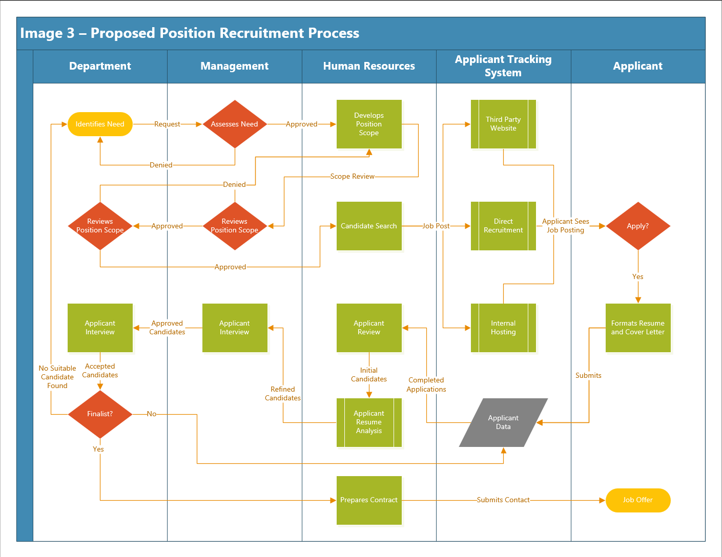

### Proposed Business Process Details

1. Company Y’s Department finds they need another employee to handle additional tasks 1,2, and 3.
2. Company Y establishes how to publicize the new position, how the position will fit in the company, and scopes out the job duties for the new position.
3. Company Y hiring staff compiles a list of basic, desired, and/or critical scope requirements. These become the keyword filter used later in the process.
4. Company Y follows through on the publication plan formulated during step 2.
5. Company Y may also reach out directly to interested parties internally desired. For critical positions this is highly recommended.
6. Company Y uses their applicant tracking system to store applicants. Then a human resource staffer reviews all applicants based on the requirements outlined in set 2, primarily using the keyword filter established. Additional analysis is performed automatically using the Resume Recommendation System. The output of the Resume Recommendation System is analysis of each applicant and a recommended candidate list.
7. Company Y begins conducting initial contact and interviews. Often this process is done by the human resources staffer.
8. Company Y begins conducting secondary interviews with selected candidates.
9. Company Y assembles all compiled data, beginning the review process for potential hiring candidate selection. During this phase Company Y is encouraged to conduct additional interviews or testing as required to reduce the number of available candidates.
10. Company Y is encouraged to do background checks at this stage. Background checks are expensive and time-consuming. Doing them at this step reduces time and material investment in undesirable candidates.
11. Company Y is encouraged to do reference checks at this point. Reference checks are expensive and time-consuming. Doing them at this step reduces time and material investment in undesirable candidates.
12. Company Y makes primary and secondary choices. If no candidate is selected, Company Y may need to restart the Position Recruitment process over, adjusting details as needed until the process is successful.
13. Company Y either receives confirmation from Primary or Secondary finalist choice accepting the job offer. At this step Company Y will begin compiling a total job offer package. This package should include all necessary information for the candidate to make a final decision or negotiate changes.
14. Company Y begins the hiring process once the candidate accepts a job offer. This process usually falls into the human resources department scope.
15. Company Y begins staging welcoming events, training, and orientation for the new employee.

### Information Flow Diagram

Image 4 – Proposed Position Recruitment Process Information Flow  
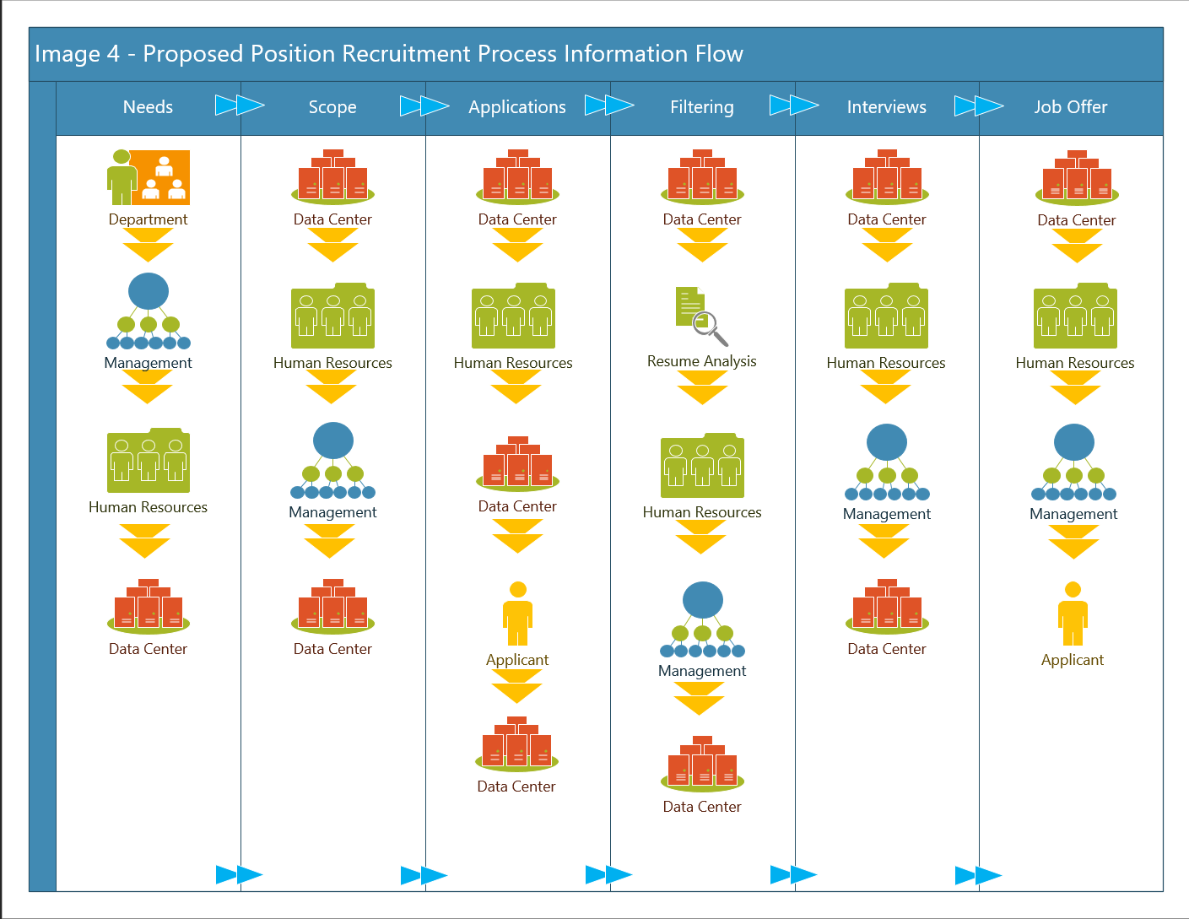

The proposed information flow diagram is presented above. Below is a breakdown of the critical information required within each column and an outline of how the data is changed through the process. It is assumed that all data starts and finishes within the Data Center the company uses to store data.

Needs – The Department identifies a need that can be filled with additional staffing. Department Leads create document detailing the need and present this to Upper Management. If Upper Management agrees with the Department assessment the document is handed off to Human Resources.

Scope – Human Resources takes the established Needs document and develops a scope of work for a new position. When this is completed, Human Resources presents the finalized position to Upper Management.

Applications – Human Resources hosts the job application post on internal or third-party applicant tracking systems. This enables potential candidates to find and apply for the new positions. As the candidate applications come in the company central Data Center can begin gathering all applications. It is at this stage that the data is the rawest as the applicant tracking systems are usually dealing with blocks of text from PDF or Word Document files.

Filtering – This stage sees the candidates keyword filtered for initial selection by the Human Resources department. To assist Human Resource staffers who may not have the subject matter expertise required to accurately identify qualified candidates, the Human Resource staffer will run the candidates through the Resume Recommendation system. This automated process can filter by Keyword as is the current common practice, but also provides insight into the resumes submitted that may allow candidates not featuring many keywords to proceed with the process. The remaining candidates are pushed to Upper Management for further selection. The analysis provided by the Resume Recommendation System can be referenced at this time as well by Upper Management to assist with their decision making.

Interviews – At this stage Human Resources makes initial contact with candidates and performs brief interviews. Then Management forms interview panels and processes all selected candidates through. At this point the pool of candidates is much reduced and very little data processing is required to proceed.

Job Offer – Human Resources takes the primary candidate information and creates a Job Offer for the candidate. Once Upper Management approves the offer is sent to the Candidate.

TODO: Once RRS is completed need to diagram the process the data goes through for final submission. Rough outline works for now.

1. RRS looks for file structure. If missing, creates file structure.
2. RRS looks for required files. If missing notifies user and exits.
3. RRS runs Job Post through analysis to generate the target values resumes need to shoot for.
4. RRS runs each Applicant through analysis to generate individual scores.
   1. This process will be very messy and require a lot of fore thought to handle outliers and exceptions.
5. RRS performs a rough correlation analysis between each Applicant and the target score.
6. RRS compiles each score for each category into a final value and sorts Applicants by final score.
7. RRS outputs all relavant data to a csv file. Keeping all job postings scorecards is critical for the future of RRS, where I hope to put a large amount of entries through some advanced machine learning analysis to provide even better recommendations.

## Use Cases

### Use Case 1: Hiring for Machine Learning Specialist I position at WolfGlyph

WolfGlyph is seeking to hire a position whose scope includes entry level understanding of Machine Learning principles, advanced statistical capabilities, machine learning pipeline skills, and strong documentation skills for code. Their current Human Resource Specialist has no experience determining which candidates may or may not have the scope requirements outlined by the keyword document provided by the Department and Management. To alleviate the stress and working hours required to come up to speed with the technical scope of the position WolfGlyph has instead developed the Resume Recommendation System that can provide additional insight to the Human Resources Specialist.

In this case, for the Machine Learning Specialist I, the Human Resources Specialist will assemble all the candidates who have completed their applications and starts the Resume Recommendation System program. The Resume Recommendation System program outputs individual candidate reviews along with a master key of all candidates and their score. Using the score provided by Resume Recommendation System the Human Resource Specialist can better select candidates to present to Management and Departments.

## User Stories (for Agile Path)

### User Story 1: Human Resource Specialist

#### “As our Human Resource Specialist, I want automatic filtering and analysis, so that I can know with confidence that my initial selections are of the highest quality.”

##### Automatic filtering and analysis

### User Story 2: Management

#### “As our Management, I want to know how my Human Resource Specialist is making their recommendations for initial candidates, having a report supporting their decisions will help.”

##### Detailed Report on how decision was made

### User Story 3: Department Lead

#### “As our Department Lead, it is really important for me to know candidates meet minimum criteria but also bring diverse views that can benefit the team, so the Resume Recommendation System needs to keep my keywords in mind but also find a few outlier candidates.

##### Resume Recommendation System must use Keywords as ONE criteria

## Analytic Needs

|  |  |  |  |  |  |  |
| --- | --- | --- | --- | --- | --- | --- |
| ***#*** | ***Analytic Process*** | **Key Business Questions** | | | | |
| KBQ1001 | KBQ1002 | KBQ1003 | … | KBQ1XXX |
| AR1001 | Sentiment Analysis – Per Resume Paragraph | X |  |  |  |  |
| AR1002 | Entity Analysis – Per Resume Paragraph | X |  |  |  |  |
| AR1003 | Content Classification – Per Resume Paragraph | X |  |  |  |  |
| AR1004 | Correlation Analysis – Compare AR1001/2/3 for resume vs Job Scope Document |  |  | X |  |  |

## Operational Needs

|  |  |  |  |  |  |  |
| --- | --- | --- | --- | --- | --- | --- |
| ***#*** | ***Operational Processes*** | **Key Business Drivers** | | | | |
| KBQ1001 | KBQ1002 | KBQ1003 | … | KBQ1XXX |
| OR1001 | Job Scope Document Keywords | X | X | X |  |  |
| OR1002 | Applicant Filtering | X | X | X |  |  |
| OR1003 | Reviewing Report on Applicants |  | X |  |  |  |

# Requirements

## BI Requirements List

Attach or provide the location of the completed requirements for this project.

TODO: I am going to use the Use Case/User Story to develop a set of requirements for this project. At this moment they are a bit squishy and not ready for final deployment but I have a rough list.

1. Provide human readable Output after doing NER analysis and correlation.
2. Utilize Keywords as an element of the score as abandoning this idea will make using RRS more difficult.
3. Easy to follow logic for the score decision. I might utilize a “match skill” system where each candidate is ranked per column and given a rank, then as each column is compiled the top candidates should have lower numbers. In treating each column like a match, I can implement some tried and true methods for calculating “player skill” without any history on the player. I am thinking about using <https://trueskill.org/> Python library for this as it allows me to caclcuate each persons score for each percieved value they generate from the analysis, allowing for any range of “match” setups.
4. After enough batches, comple all job records with which applicants were actually selected and which was hired, and complete a true Machine Learning model for classification.

## Screen Layouts or Prototypes

Provide screen layouts and document User Interface (UI) Prototypes. Explain high level flow of user navigation and functionality.

TODO: These are still being designed. Until I have completed the whole program I will not have a solid User Interface for the program or output file. Below is my broad scope for the UI.

Main Menu

1. Process Candidates
2. New Job Post
3. First Time Setup
4. Exit

Order wise I added them in order of most likely to be used. A user should only have to setup the system once per computer, so that is the last option in front of Exit. The Second most likely action will be entering a new job post for the system to prep for. After that it will be processing candidates.

Eventually I would like to have the system be more than a dos interface, but I am working with a proper time crunch so I am limited.

The main menu is all I need as the system is designed to be self sufficient and require minimal user input, so long as user has the required files. I imagine I will include some informational outputs for the system to let the end user know at what stage the process is at. Otherwise the end user only needs to select their option, read the DOS output for any errors, and exit the program once done.

## Report Layouts

Provide the report layouts and explain how frequently the reports are required to run.

TODO: Report layouts are going to be influx until I finalize my final outputs. I am going to lay things out partially in this order below. Using a table as an example as the final output for this phase is just a csv file.

|  |  |  |  |  |  |  |  |  |  |
| --- | --- | --- | --- | --- | --- | --- | --- | --- | --- |
| Candidate | Email | Total Score | Keyword Score | Resume Topics | ??? | ??? | ??? | ??? | ??? |
| Samuel Wolfe | Wolfesamk @gmail.com | 85% | 80% | Management, IT, Projects | ??? | ??? | ??? | ??? | ??? |

I need to exiriment with putting mutlople resumes through my analysis to see what their outputs look like and how to compare them to the Job Posts own score. After I do that I can more easily determine what information is key to output when compared to the design requirements from the User Stories. Because the intention is to eventually see if hiring people who only match keyword filters so well is better for diversity of background, opinion, and culture. Eventually I want to find what I am calling the Keyword Threshold to find the best balance by general job position and industry between candidate resumes and the job posting as conceptualized by this image. Below.

Image 5 – Keyword Threshold Concept

## Non-Functional Requirements

|  |  |  |  |  |  |
| --- | --- | --- | --- | --- | --- |
| **Tool Operations** | **User Types/Roles** | **# of Users** | **# of Concurrent users** | **Growth rate per year** | **Comments** |
| Total users |  |  |  |  |  |
| Total # of primary users |  |  |  |  |  |
| Total # of secondary users |  |  |  |  |  |
| Total # of tertiary users |  |  |  |  |  |
| Internal only users |  |  |  |  |  |
| External users |  |  |  |  |  |

* Status is as follows: **Proposed**-requirement has been suggested; **Reviewed**-has gone through a peer review; **Approved**-requirement was allocated to a baseline; **Verified**-has gone through verification & passed. Additional follow on statuses for design & QA documents should include Tested-has been developed & through a testing cycle to ensure proper action; Deferred-will be implemented in a future release; Cancelled-a decision was made not to implement the requirements at all; Rejected-the idea was never approved.

| **#** | **Question** | **Status\*** | **Additional Info** | **Response** |
| --- | --- | --- | --- | --- |
| NFR1001 | What is the future growth for the number of users? | Proposed | Captured to ensure the solution provided can accommodate the projected # of users |  |
| NFR1002 | How many concurrent users will access the application on average? | Proposed | There may be 50 people who may use the system but the anticipated # of people who would use it at the same time may only be 10. It will affect the solution design. |  |
| NFR1003 | What instances will there be an increase in the application usage? (Peak usage) | Proposed | Day of week, time of day, seasonal, etc. The solution might be accessed the most from 7AM to 10 AM because the users need to assess what happened in the last 24 hours. Or it may have heavy usage at the start of the month for planning purposes. These all affect the design of the solution. |  |
| NFR1004 | How many concurrent users will access the application during peak? | Proposed | The volume of simultaneous users will affect the design of the system. The number can be supplied as ranges; a specific single number is not necessary. The answer can be a guestimate. Please supply how the numbers were calculated, such as 2 users per store times 100 stores. |  |
| NFR1005 | Where will your users access the application from? | Proposed | Home Office, Stores, DC’s, Banners, Countries, etc. |  |
| NFR1006 | If you have international users, will the application need to be translated? If so, what languages? | Proposed |  |  |
| NFR1007 | How will your users access the application? | Proposed | From the Wire, Retail Link, Internet, or other portal |  |
| NFR1008 | Will users require ad hoc capabilities? If so, how many users? | Proposed | The count can be a range and is understood to be an approximate number. |  |
| NFR1009 | Will external vendors need access to the application? If so, how many users? | Proposed |  |  |
| NFR1010 | Will you need to schedule and/or email reports to your users? | Proposed |  |  |
| NFR1011 | Are the data elements you need already available on existing databases? If so, what platforms? | Proposed | The interviewees may or may not know this. At this point the answer can be and should be very high level, such as a system maintained by an outside vendor or Teradata. |  |
| NFR1012 | Disaster recovery: If the system were to be brought down due to fire or some other catastrophe, realistically how soon would disaster recovery need to be completed? | Proposed | Everyone wants their system back immediately. But in a state of emergency, how long could your area operate without current information? |  |
| NFR1013 | Training: How many people by communication channel will need training? | Proposed | The types of training that may be needed would be face-to-face, WebEx or CBT. Not all people will need in-person training. Training may be a one-time or need to be accessed on as needed basis. |  |
| NFR1014 |  | Proposed |  |  |
| NFR1028 |  | Proposed |  |  |

## Information Availability Requirements

Resumes classify under Personally Identifiable Information and thus require the highest sensitivity with information availability. Per WolfGlyph Information Security Practices Policy, Personally Identifiable Information falls under Data Protection Level 2.

|  |  |
| --- | --- |
| **Data Protection Level** | **Description** |
| DPL 1 | Public information, non-identifiable information, non-proprietary data |
| DPL 2 | Personally Identifiable Information, Active projects, business data less than 5 years of age |
| DPL 3 | Proprietary Data, Human Resource Documents, NDA applicable projects |

Because WolfGlyph classifies the data required for processing as DPL 2, data storage and access will require individual and software background checks compliant with ISO 27000 Series and NIST standards.

During Phase 1 of development for Resume Recommendation System the process will be more manual. Staff will be required to collate applicants who pass minimum requirements checks into the same folder as the Resume Recommendation System script. This requirement during Phase 1 means the staffer running Resume Recommendation System must do so using company managed and secured systems.

## Availability

|  |  |  |
| --- | --- | --- |
|  | |  |
| *Report Refresh Frequency* | As needed during hiring process. | |
| *Data Schedule Prerequisites* | This process requires at least one applicant’s info to be stored within the applicant tracking system database prior to running. As such the date of prerequisites is n-1 where n is date of running the report. | |
| *Data Latency* | Data should be refreshed as needed. There are costs for running Resume Recommendation System for over 200 total resumes. | |
| *Business Criticality* | Low Critical | |
| *History* | 1 unit of data is required, Resume Recommendation System cannot process without resumes. | |
|  | | |
| *Archiving Strategy* | 1 Master report will be saved, with backup saved elsewhere. As number of applicants increases the report will add them sequentially, preventing applicants from being added twice and preserving memory. | |
| *Current # of reports in archive, if any* | In total 2 copies of the report for each job posting will be archived within the system. | |

# Supporting Information

## Assumptions

The following table is a list of assumptions for the Resume Recommendation System.

|  |  |
| --- | --- |
| **Assumption** | **Definition** |
| HIPAA Minimum Requirements | Resume Recommendation System assumes that Resumes provided for analysis are pre filtered for minimum HIPAA related requirements to prevent HIPAA information from being introduced into the Resume Recommendation System. |
| Resume Naming Convention | Resume Recommendation System assumes that resumes and cover letters provided for analysis are named in the following schema. `resume_lastName_firstName.pdf`  `cover_lastName_firstName.pdf` |
| File Location | The Resume Recommendation System assumes that resumes and cover letters provided for analysis are in the following folder relative to the location of the script. The main.py is in the ResumeFilter location.  */ResumeFilter/JobApps/Job{job app ID}/RawApps |
| Startup Files | The Resume Recommendation System assumes that Staff have at least one job posting saved to the following format.  `jobPost_{id}.pdf` - where {id} matches id for job. MUST BE UNIQUE.  Additionally the Resume Recommendation System assumes that Staff have a text file containing keywords saved with the following format.  `keywords_{id}.csv` - where {id} matches id for job. MUST BE UNIQUE. Columns are `minimum` and `preferred`.  BOTH files must be saved to the following location for the Resume Recommendation System to work.  */ResumeFilter/JobApps |
| Training | The Resume Recommendation System assumes that Staff utilizing the program are adequately trained in Windows OS standards and use of the program itself. |
| Privacy | The Resume Recommendation System assumes that Applicants are informed their information may be processed using third party tools on prem and cloud based. |
| Software | The Resume Recommendation System assumes that company computer environments are Windows 10/11 and have Python version 12.0.0 installed. |

## Exclusions

The following will not be addressed at this time during the Resume Recommendation System development.

|  |  |
| --- | --- |
| **Exclusion** | **Definition** |
| Custom Named Entity Recognition | Resume Recommendation System will not include a custom Named Entity Recognition dictionary at this time. Later an additional project will be developed for this purpose. |
| Advanced Recommendation | Resume Recommendation System will not feature advanced classification analysis at this time. The data requirements cannot be satisfied with resources on hand during this phase. After the system has been in use for a |
| Applicant Tracking System Integration | The Resume Recommendation System will not feature dedicated API support for Applicant Tracking Systems of any kind. If this feature is desired it can be added during later development. |

## Training Requirements

Define the training requirements for this project. Include the training schedule, information about training material, user documentation and who is responsible for the training.

Training is strongly encouraged for use of the Resume Recommendation System. WolfGlyph will provide in-depth training and training documents to initial staff as part of the implementation process. After that period, it is required of the company or departments to maintain training or any training refresh courses they develop after provided training from WolfGlyph.

It is the responsibility of the Human Resources and Information Technology Departments to provide training after initial training provided by WolfGlyph.

Training Prerequisites  
Required: Knowledge of Microsoft Windows 10/11, intermediate Windows File Explorer skills, Microsoft Excel experience.  
Recommended: Python experience.

Training to use the Resume Recommendation System will take around an hour. During the training process staff will be shown how to run the initial environment setup required to run the Resume Recommendation System, how to create or rename file folders within File Explorer, how to rename PDF files, how to navigate the Resume Recommendation System file structure once the environment is established, and how to interpret the results.

TODO: Write up training document once finished with the program.

## Review Records

The included file(s) contain the record(s) of the Requirements Review Process.

TODO: Will fill in details here after I turn this document in for the User Design Experience assignment.

# Revision History

The following table contains the revision history of this document.

|  |  |  |  |
| --- | --- | --- | --- |
| Revision Number | Revision Date | Author and Title | Description |
| Each time changes are made to the document, increment the document revision number starting from Initial Version | Date when the document is revised | Name and title of the person making the changes | Brief description of what is changed in the document |
| 1 | March 16, 2024 | Samuel Wolfe | Started document, got to Section 3.3. |
| 2 | March 22, 2024 | Samuel Wolfe | Finished Section 3. Reviewed Section 4 and 5. |
| 3 | March 26, 2024 | Samuel Wolfe |  |
|  |  |  |  |
|  |  |  |  |
|  |  |  |  |
|  |  |  |  |

# Abbreviations

The following table contains common abbreviations that are used in this document.

|  |  |
| --- | --- |
| Abbreviation | Description |
| ATS | Applicant Tracking System |
| RRS | Resume Recommendation System |
| Py | Python |
| OS | Operating System |
| ML | Machine Learning |
| API | Application Programming Interface |
| PDF | portable document format |
| DLP |  |
|  |  |
|  |  |
|  |  |
|  |  |

# 

# Glossary

The following table contains unique terms and their descriptions that are used in this document.  
TODO: After receiving feedback on this new proposal and UX documents turn in, I need to have multiple people not as close to the topic as I am review this document. They will need to highlight every single word, term, or element they do not understand so I can either clarify or add it to the glossary here.

|  |  |
| --- | --- |
| Term | Description |
| Python |  |
| Machine Learning |  |
| Sentiment Analysis |  |
| Entity Analysis |  |
| Content Classification |  |
| Correlation Analysis |  |
| Job Scope |  |
| Applicant Tracking System |  |
| Human Resources |  |
| Resume |  |
| Cover Letter |  |
| Minimum Applicant Filtering |  |
| Applicant Filtering |  |
| Keyword Analysis |  |
| Applicant Score |  |
|  |  |
|  |  |
|  |  |
|  |  |
|  |  |
|  |  |
|  |  |
|  |  |
|  |  |